LAB1
Norah Alolayan
431201620

Part 1: Capturing HTTP Traffic

Task 1: Start Wireshark and capture packets
Task 2: Filter HTTP packets and analyze them

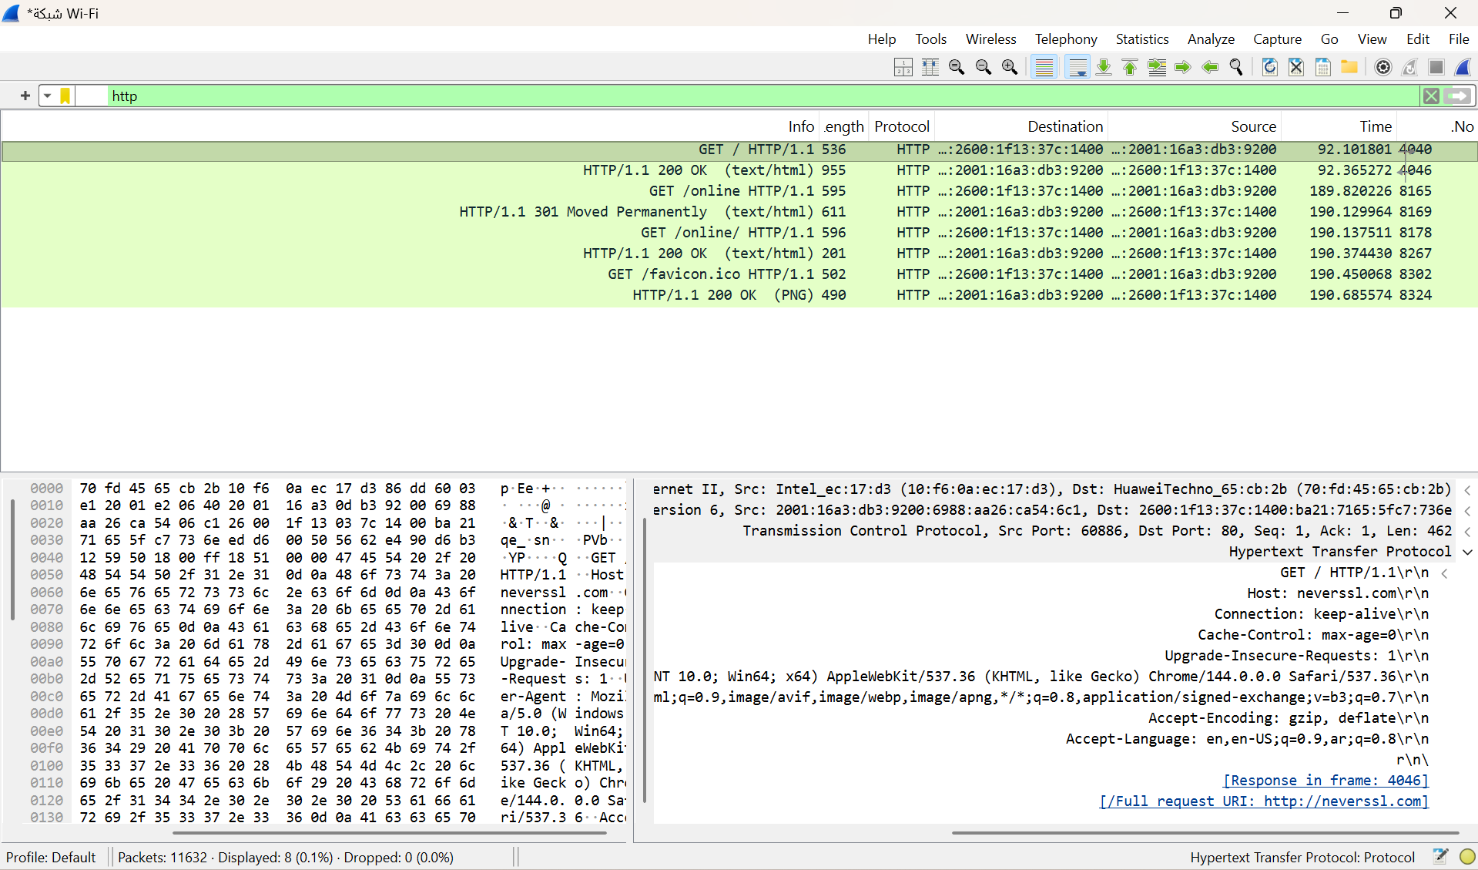
http_request.png

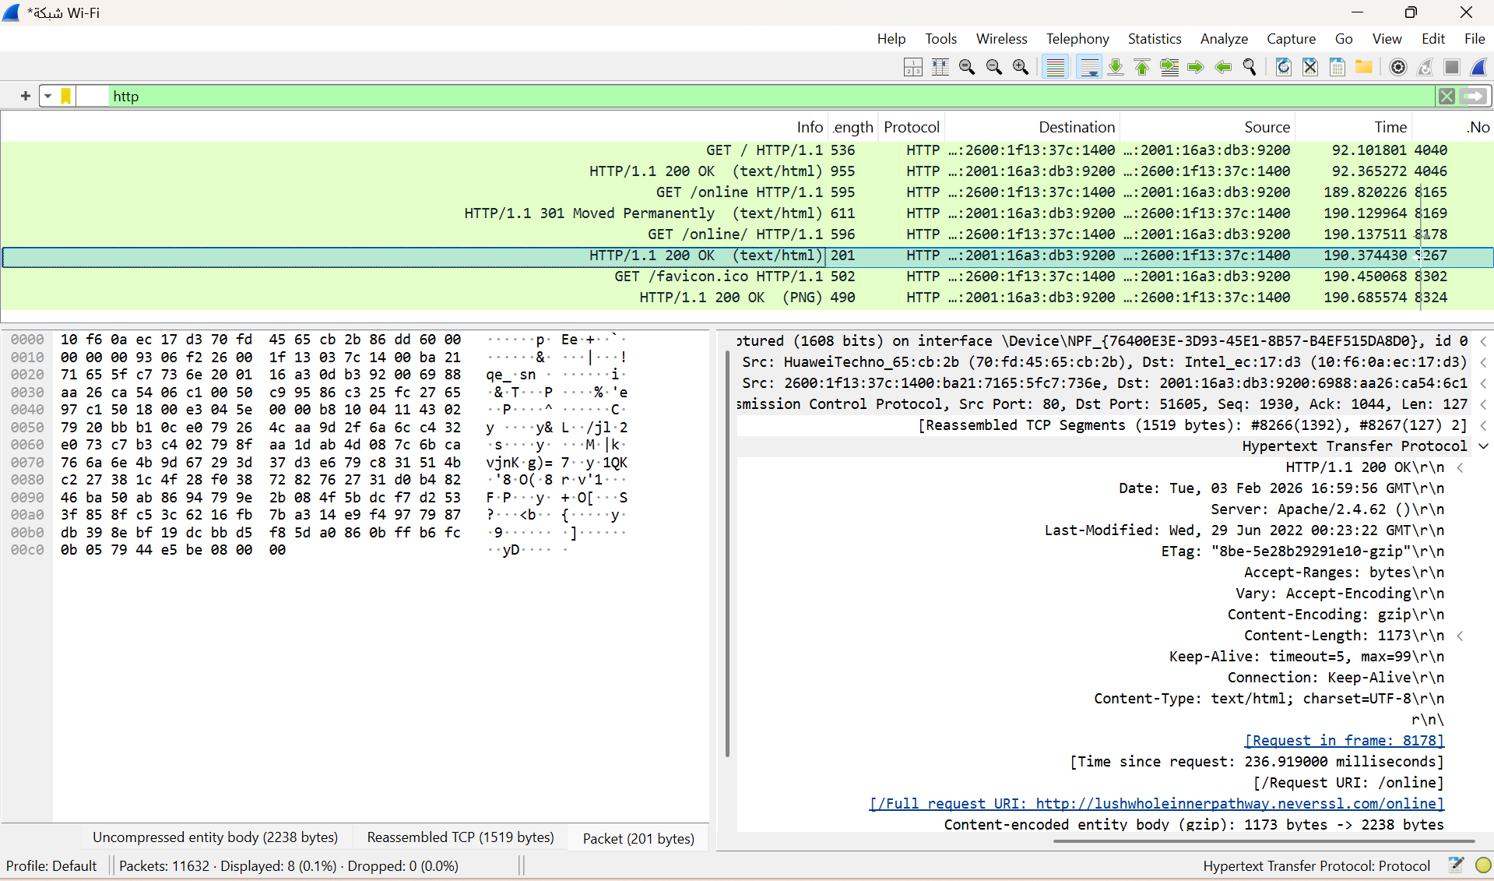
http_response.png

Part 2: Analyzing TCP/IP Traffic
Task 1: Filter TCP packets
Task 2: Analyze TCP handshake and investigate Data Transfer and Termination
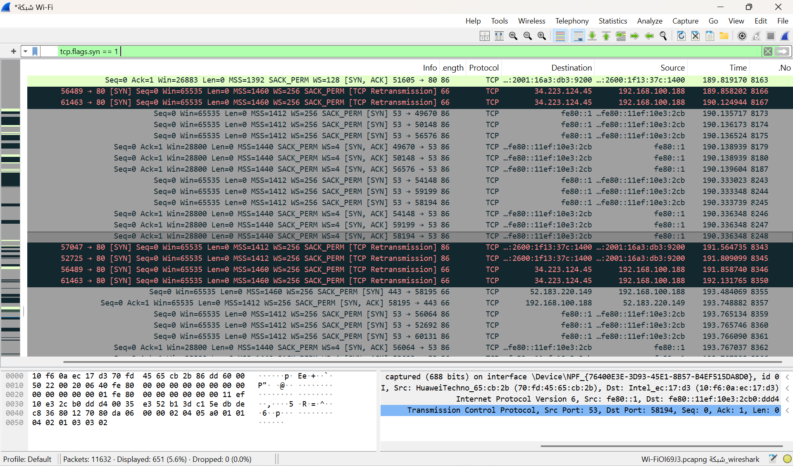
tcp_handshake.png
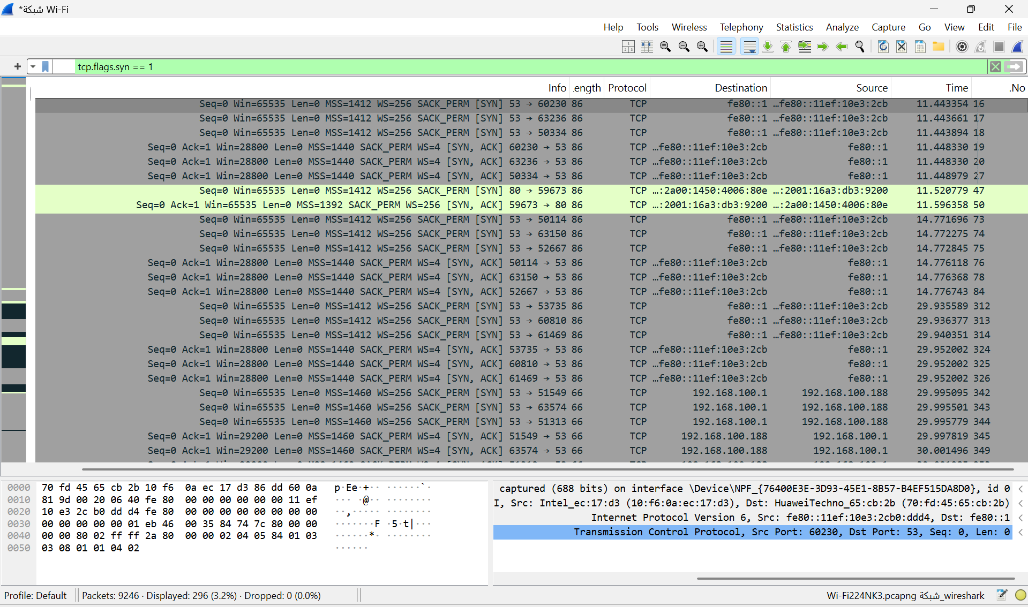
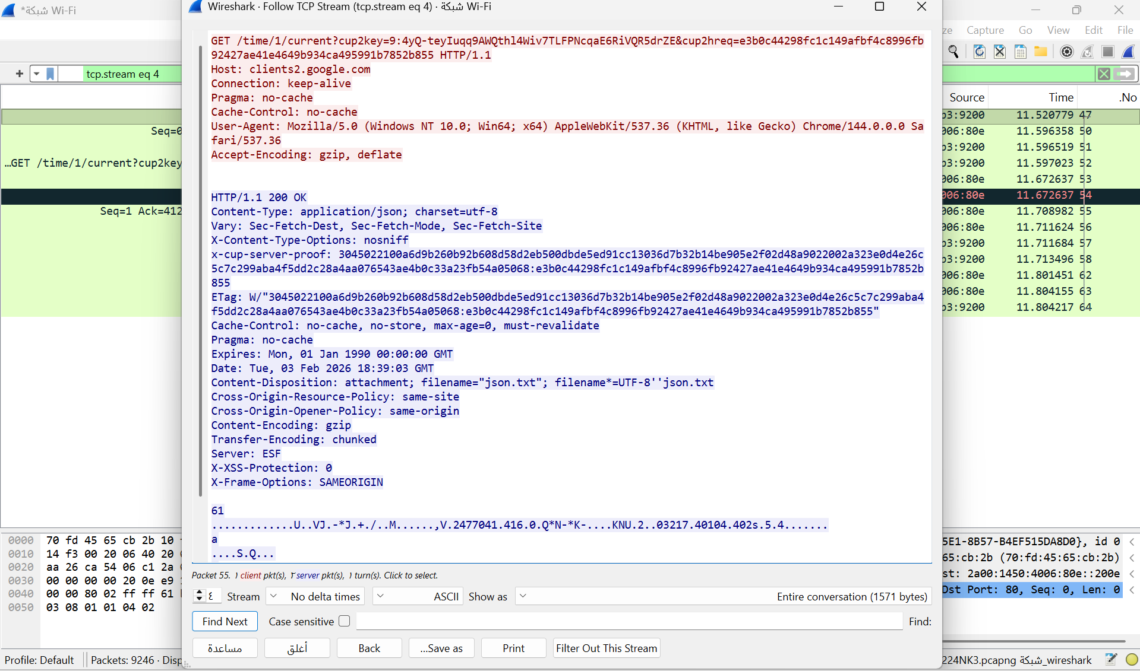
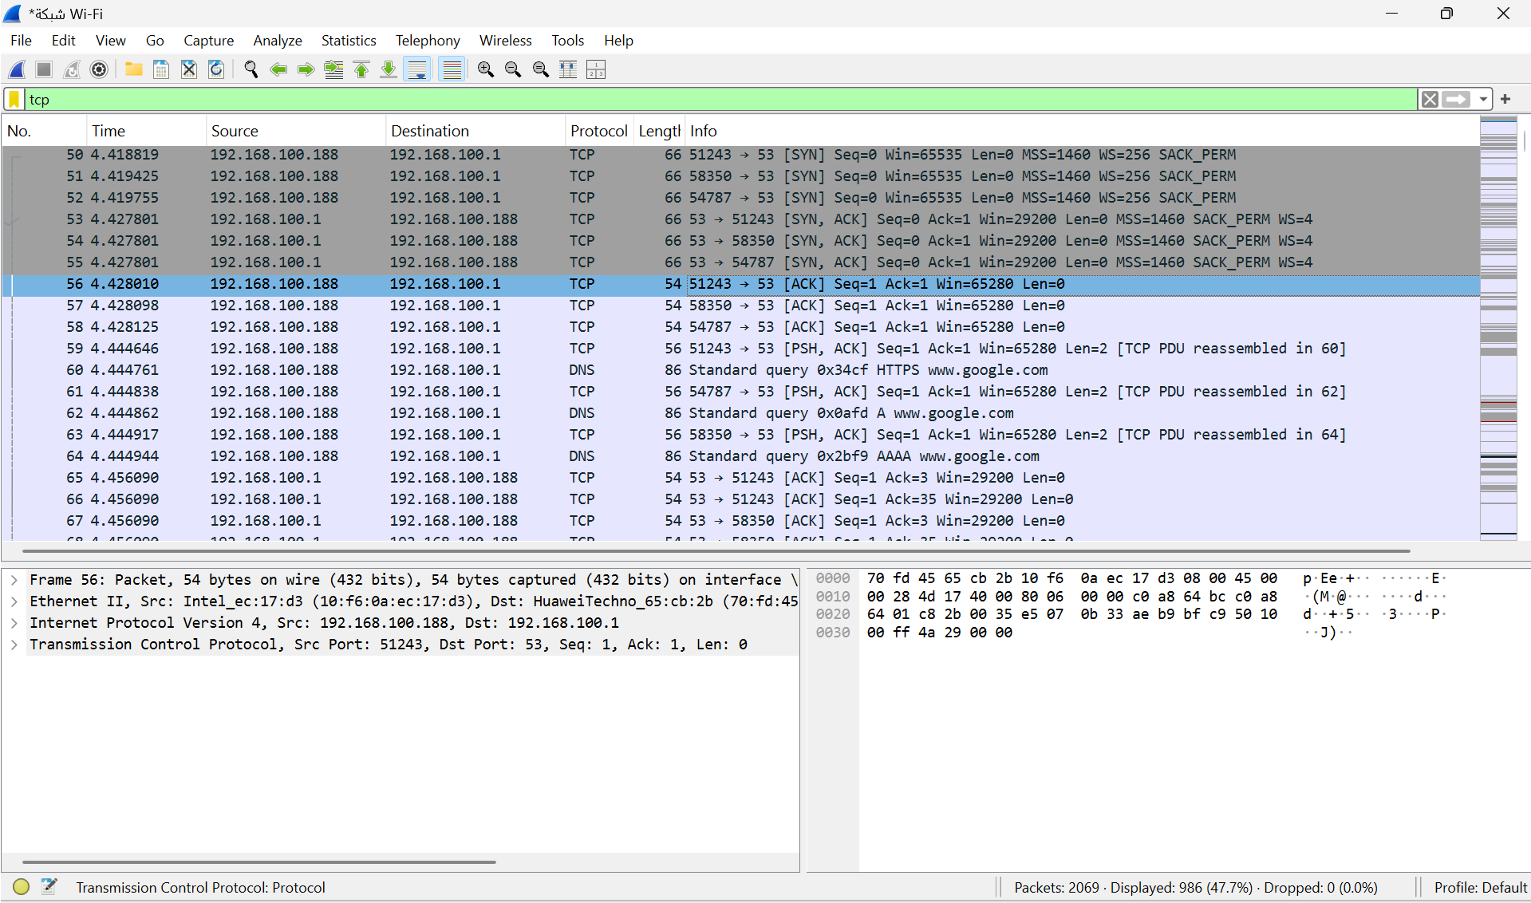

The TCP three-way handshake can be identified by observing the SYN, SYN-ACK, and ACK packets, which appear consecutively within the same TCP stream. This sequence confirms that the TCP connection was successfully established between the client and the server.

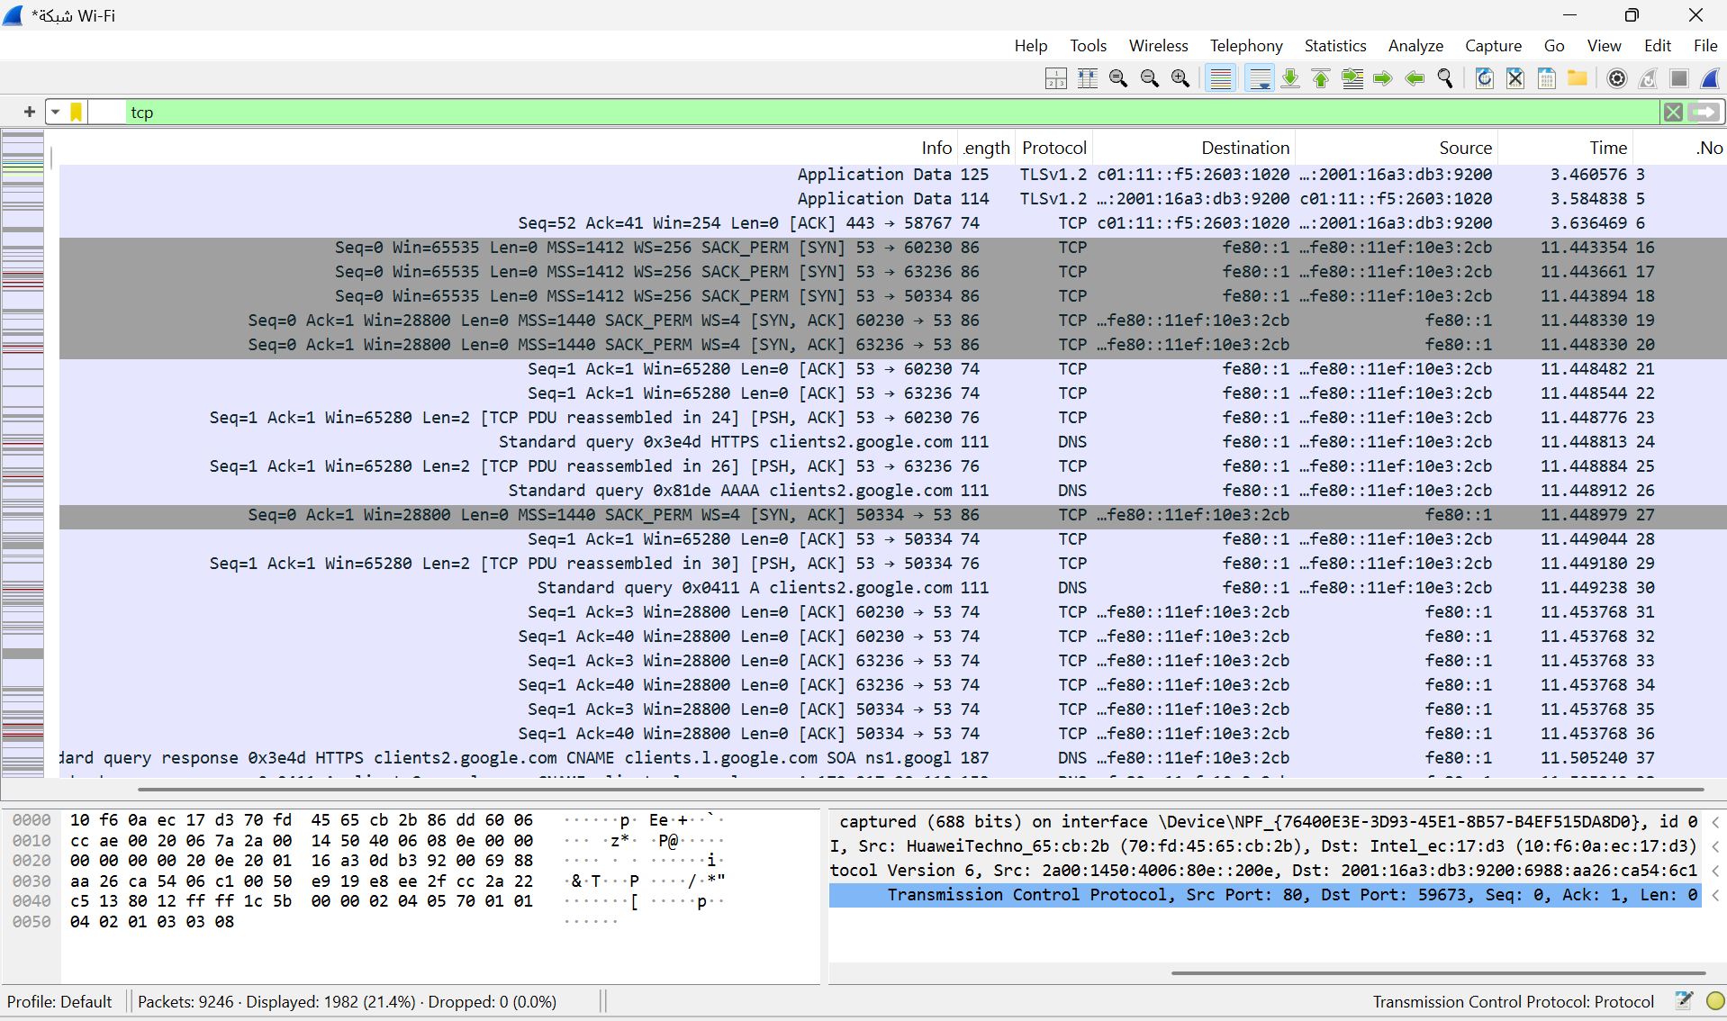
TCP_data.png

This image illustrates TCP packets involved in data exchange after the TCP connection was successfully established

TCP_connection_termination.png
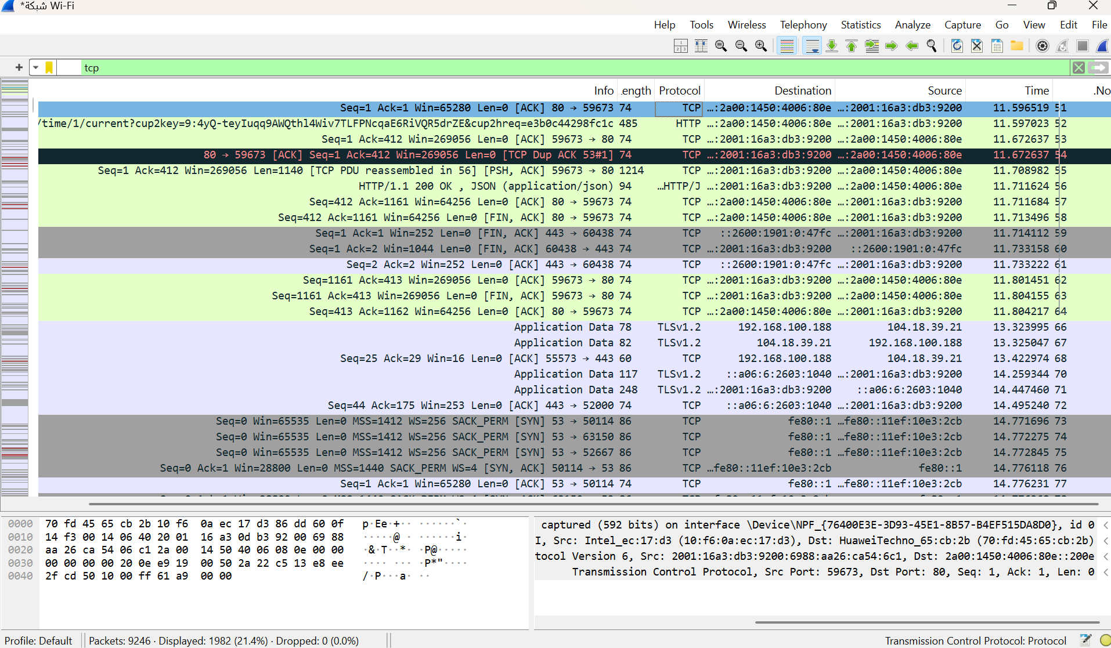

This figure illustrates TCP packets involved in closing the TCP connection, where FIN and ACK flags indicate the termination process between the client and server

Part 3: Capturing and Analyzing UDP Traffic
Task 1: Generate UDP traffic and capture packets
Task 2: Filter and analysis UDP Packets
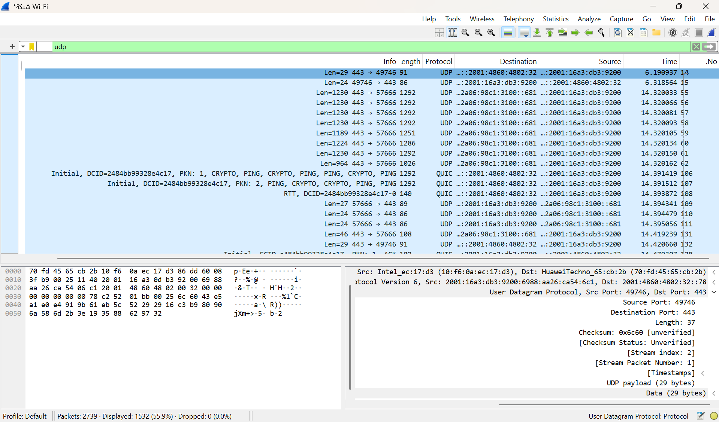
udp_packet.png

This figure shows captured UDP packets during data transmission, illustrating how UDP transfers data without prior connection setup while emphasizing speed over reliability

Based on the captured UDP packet shown in the figure:
Source Port: 49746
Destination Port: 443
Protocol: UDP (User Datagram Protocol)
Packet Length: 37 bytes
UDP Payload Length: 29 bytes

Compare the simplicity of UDP headers with TCP headers
UDP has a very simple header with only a few basic fields and does not include sequence numbers, acknowledgments, or connection control mechanisms. In contrast, TCP headers are more complex and contain many additional control fields to support reliable communication. This makes UDP headers much simpler than TCP headers. As a result, UDP has less overhead compared to TCP

Part 4: Comparing TCP and UDP by filling in the following tables
Task 1: Fill in the following table and provide reasons
 | TCP or UDP | Reasons
Reliability and Connection Establishment | TCP | Because it provides 3-way handshake connection(SYN,SYN\ACK,ACK), ensuring both devices are ready before data transmission starts and reducing the risk of data loss
Data Integrity and Ordering | TCP | Because it uses sequence numbers, acknowledgments, checksums, and retransmission mechanisms to recover lost or corrupted packets

Task 2: Identify the use Cases and Performance of TCP and UDP
 | TCP | UDP
Use cases | Web browsing (HTTP/HTTPS), email, file transfer (FTP), remote access (SSH) | Video streaming, online gaming, Internet voice calls
Performance | Slower but reliable due to acknowledgments and retransmissions | Faster with low latency but less reliable

